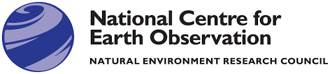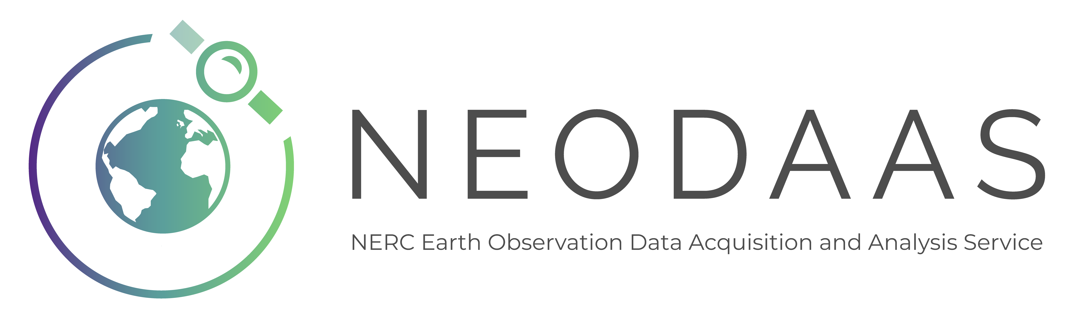

NEODAAS Request Form for Solar-tracking Radiometry Platform (So-Rad) Deployment

Principal Investigator (PI) Details
Please provide details of the PI for the request. Please note that NERC rules requires PhD students to ask their supervisor to act as PI.

Name:
Email:
Institute and Department:
Telephone:

Collaborator details
Please provide details of collaborators for the request.

Collaborator name:
Collaborator email:
Collaborator Institute and Department:
Collaborator telephone:
For additional collaborators please list their details in this field:

Deployment Details
Please use this section to provide details of the anticipated data set you will collect with the So-Rad system. Please note that short deployments (< 2 weeks) cannot normally be supported unless the required installation materials are already available, and the onsite operator has already received the required training.

Deployment location (in case of a ship, include name and approximate ship-track):

Start date of deployment and mobilisation location:

End date of deployment and de-mobilisation location:

Installation Details
The So-Rad system is a radiometry platform designed to retrieve above-water reflectance from ships, large buoys, or fixed platforms. It provides mounting for three separate optical sensors that measure downwelling irradiance (mounted separately from the other sensors with an unobstructed view of the sky), sky radiance and water radiance (both mounted to a rotating platform near to the control unit). The installation consists of attaching the control unit, motor enclosure, sensors and optical cables, and two GPS antennas. An inventory of the So-Rad system is shown in Figure 1a.

In this section, we assess the feasibility of the So-Rad installation location, including the need to produce platform-specific mounting solutions. Photographic examples of past installations are show in Figure 1b and 1c. Supporting information, including a full installation guide, can be found here: https://monocle-h2020.eu/Sensors_and_platforms/Solar_tracking_radiometry_platform_en.

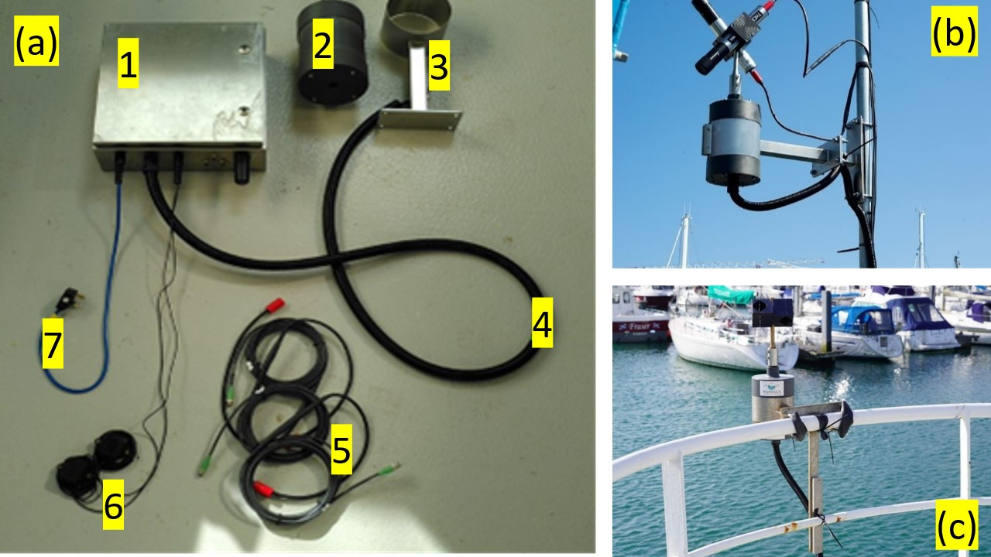

Figure 1. (a) Inventory of a So-Rad system (excluding radiometers). 1. Control unit, 2. motor enclosure, 3. mounting bracket, 4. motor cables, 5. sensor cables, 6. GPS receivers and 7. AC mains power cord. The control unit and motor enclosure are connected by a non-detachable conduit. (b, c) Examples of installed So-Rad motor enclosure on a vertical pole and a horizontal railing

User questions:

1. What is the required cabling length between the motor enclosure (holding radiance sensors) and the control unit?

2. What is the required cabling length between the downwelling irradiance sensor and the control unit?

3. What power source is available? (A minimum of 12VDC@2A, 24 VDC@1A, or 220-240 AC power is required).

4. What is the required cabling length between power source and mounting location?

5. Can the power source be easily switched on and off?

6. What is the approximate length and height (deck to water) of the platform/vessel?

7. Where on the vessel will the instrument be mounted? (The view to water must be unobstructed in as wide an arc as possible. The bow of the vessel is recommended. For fixed platforms, north-facing is recommended. The rear and wake of moving vessels must be avoided). Please include an annotated photo and/or drawings.

8. Where on the platform can the downwelling irradiance sensors be installed? This must be away from any shading structure but below lightning rods. Please include an annotated photo and/or drawings.

9. What mounting structures are available? (e.g. railings with dimensions (heights, diameter, box or cylindrical), and distances between specified).

Project Details

It is expected that the data collection and processing provided through NEODAAS will form part of a larger project, through which you will cover your own staff time for data analysis. The information provided here will be used as part of the review process to determine if NEODAAS can support the application for data collection and routine processing. Around two or three paragraphs of text are expected in each of the ‘background’, ‘description of project’ and ‘use of requested Earth Observation data’ sections to provide sufficient detail during the review process.

Title of project:

Duration of project:

NERC science themes:
- Climate system
- Biodiversity
- Sustainable use of natural resources
- Earth system science
- Natural hazards
- Environment, pollution & human health
- Technologies

Source of funding:

Background and rationale for project:

Description of project research/activity:

Expected outputs (data*, research papers, PhD theses, published reports, conference papers, etc.):

* for ancillary (optical, biogeochemical) samples and data collections, please describe how and where these will be shared with the wider scientific community. The use of a centralized and dedicated data repository such as SeaBASS or LIMNADES is encouraged. So-Rad data are made available through a dedicated processing system and publicly shared under CC-BY-NC license.

